**U01E03 – Php Scripts - I**

Make the following scripts using html and php.

For these scripts that are simple, you paste the code directly after the statement.

1. Develop a php script to:

* To create a variable that indicates the type of geometric figure: square, rectangle, triangle and depending on the type of figure that you have put in it, it tells you how the value of the perimeter would be calculated.

For example: You should display something like: “To find the perimeter of a square you must know the length of one of its sides and multiply it by 4”…

* Develop a php script for a Calculator with basic operations. Create a php program that defines 3 variables: operand1, operand2, operationtype and based on them perform the operation described in operationtype (+,-,*,/).

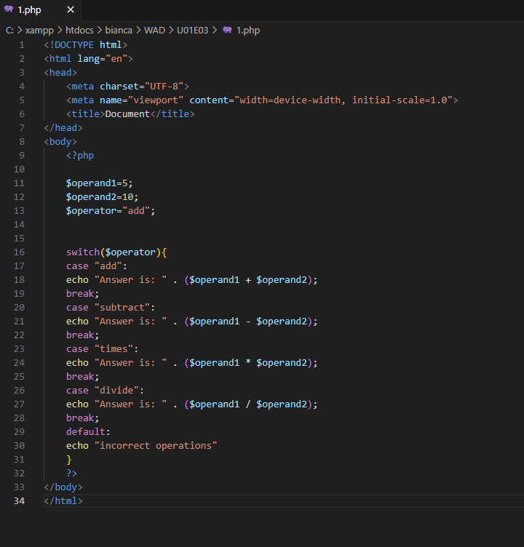

1. With the array created previously in which we have the days of the week and associated the meal of the day and a variable that indicates the day of the week, using a “switch” type structure depending on the day, write on the screen what they are the meals.

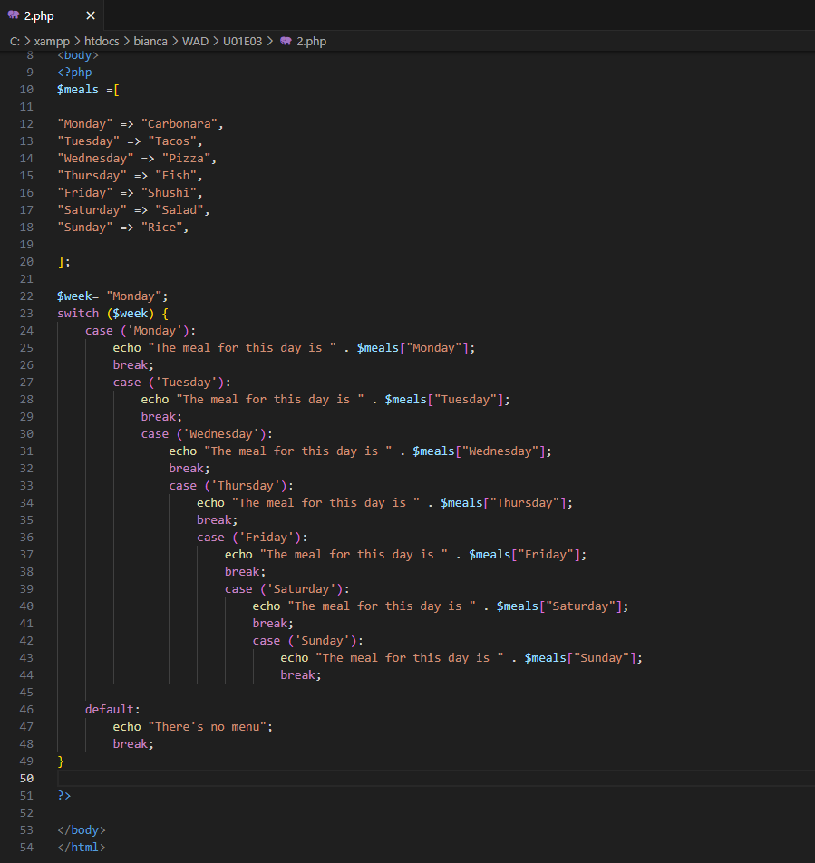

1. You have a number that can between 1 and 100. The script using a “for” structure, should calculate the average of the first “n” numbers. That is to say: if n=4, it will calculate the average of 1+2+3+4. If n=7 it will calculate the average of 1+2+3+4+5+6+7 and display it on the screen.

